Connect SQL Server from Local DB

1. Download On-premises Data Gateway

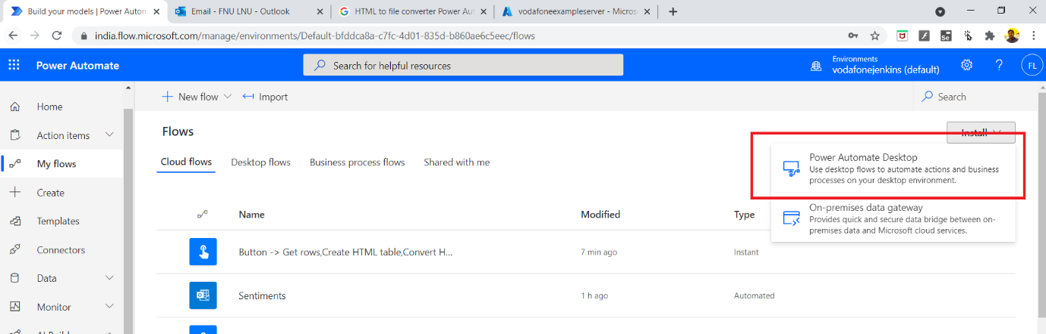

1. Configure with your Email id (ex: [admin@vodafonejenkins.**onmicrosoft.com**](mailto:admin@vodafonejenkins.onmicrosoft.com))
2. Follow this steps
3. In the gateway installer, keep the default installation path, accept the terms of use, and then select **Install**.

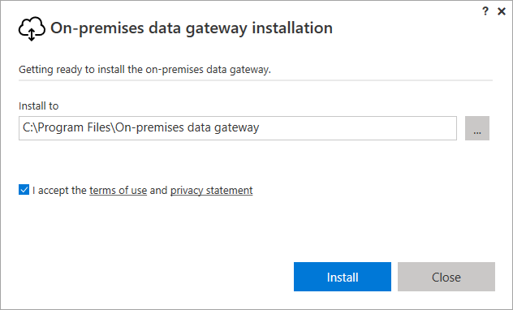

1. Enter the email address for your Office 365 organization account, and then select **Sign in**.

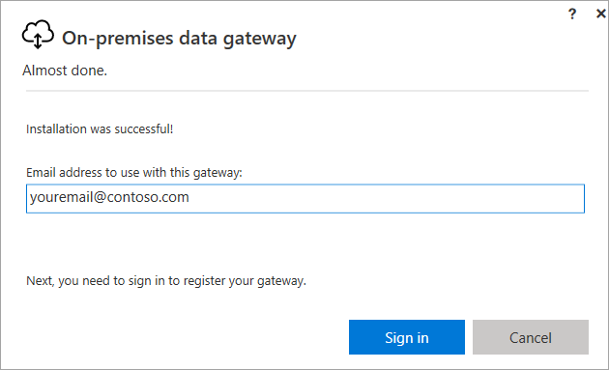

Select **Register a new gateway on this computer** > **Next**.

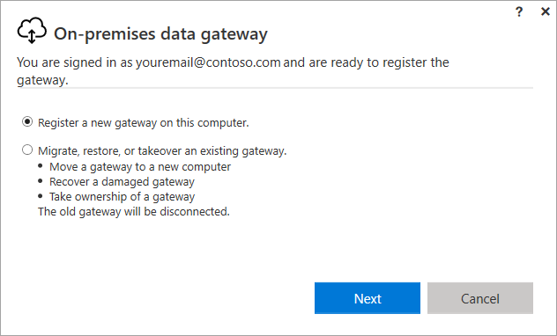

1. Enter a name for the gateway. The name must be unique across the tenant. Also enter a recovery key. You'll need this key if you ever want to recover or move your gateway. Select **Configure**.

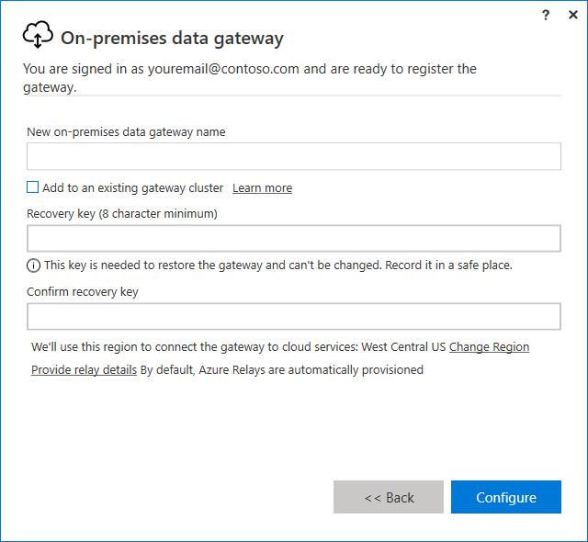

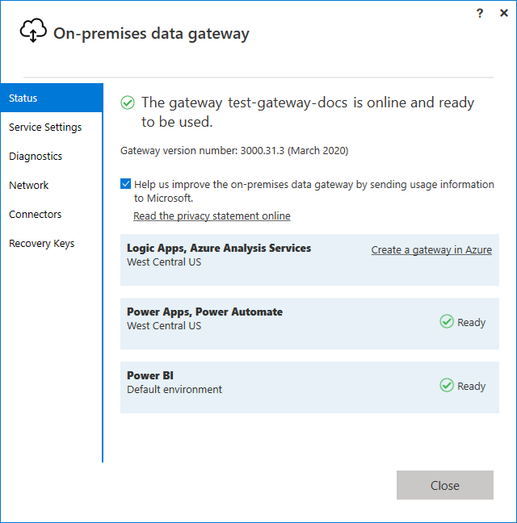

Now that you've installed a gateway,

1. Create an Instant Cloud flow
2. Add SQL Connector -Get Rows

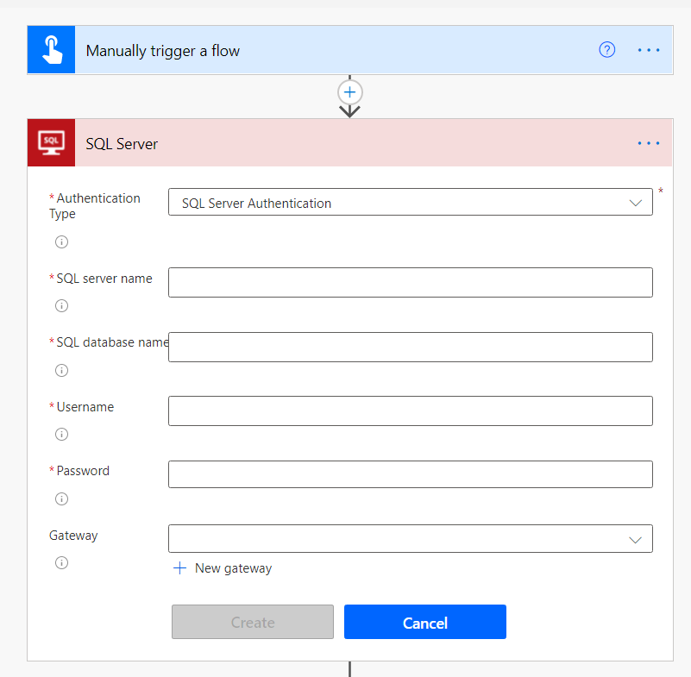

1. Configure your SQL Server connection

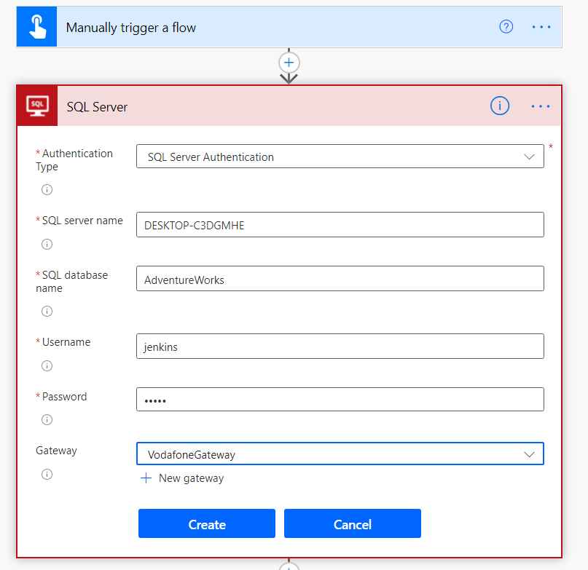

1. Create
2. Then Enter Server Name and database Name
3. Select Table Name

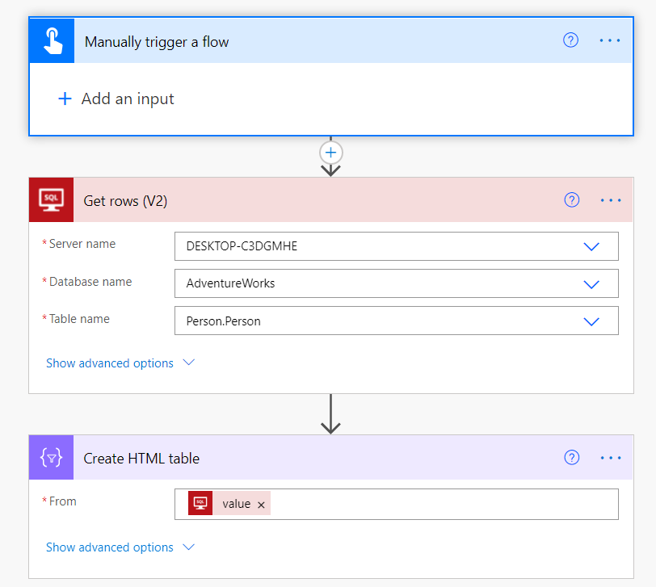

1. Convert the data to HTML
2. Test it